Atitit 分词token stack法

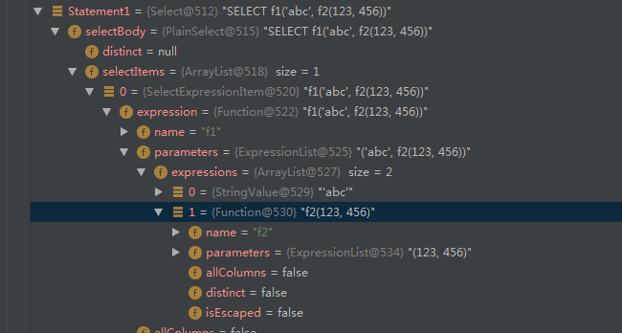

public class QlExpress {  
@SneakyThrows  
 public static void main(String[] args) {  
 String s="f1('abc',f2(123,456))";  
 String sql="select "+s;  
 Statement Statement1 = CCJSqlParserUtil.*parse*(sql);  
 Select select = (Select) Statement1;  
 }  
}

{

"allColumns":false,

"distinct":false,

"escaped":false,

"name":"f1",

"parameters":{

"expressions":[

{

"notExcapedValue":"abc",

"value":"abc"

},

{

"allColumns":false,

"distinct":false,

"escaped":false,

"name":"f2",

"parameters":{

"expressions":[

{

"stringValue":"123",

"value":123

},

{

"stringValue":"456",

"value":456

}

]

}

}

]

}

}

package org.chwin.firefighting.apiserver.QL;  
  
import com.alibaba.fastjson.JSON;  
import lombok.SneakyThrows;  
import net.sf.jsqlparser.expression.Function;  
import net.sf.jsqlparser.parser.CCJSqlParserUtil;  
import net.sf.jsqlparser.statement.Statement;  
import net.sf.jsqlparser.statement.select.PlainSelect;  
import net.sf.jsqlparser.statement.select.Select;  
import net.sf.jsqlparser.statement.select.SelectExpressionItem;  
import net.sf.jsqlparser.statement.select.SelectItem;  
  
import java.util.List;  
  
public class QlExpress {  
 @SneakyThrows  
 public static void main(String[] args) {  
 String s = "f1('abc',f2(123,456))";  
 String sql = "select " + s;  
 Statement Statement1 = CCJSqlParserUtil.*parse*(sql);  
 Select select = (Select) Statement1;  
 List<SelectItem> li = ((PlainSelect) select.getSelectBody()).getSelectItems();  
 SelectExpressionItem sei = (SelectExpressionItem) li.get(0);  
 Function funAst = (Function) sei.getExpression();  
 System.*out*.println(JSON.*toJSONString*(funAst, true));  
 }  
}